Registration Information  Ridgecrest Conference Center -Ridgecrest, NC  Mountain Laurel Room Accommodations- Features 2 Queen size beds. Total Weekend Cost is broken down based on the number of guests in each room.  Single/Double Occupancy- $109 per night  Triple Occupancy- $119 per night  Quad Occupancy- $129 per night  Meal Plan-Ridgecrest offers a Meal Plan at their Dining Hall for 3 meals on Saturday and breakfast on Sunday- $44 per person  The Friday evening meal and Sunday lunch will be on your own. |  |  |   REFRESH  An uplifting, encouraging, & supportive ministry specifically designed for Pastors’ Wives  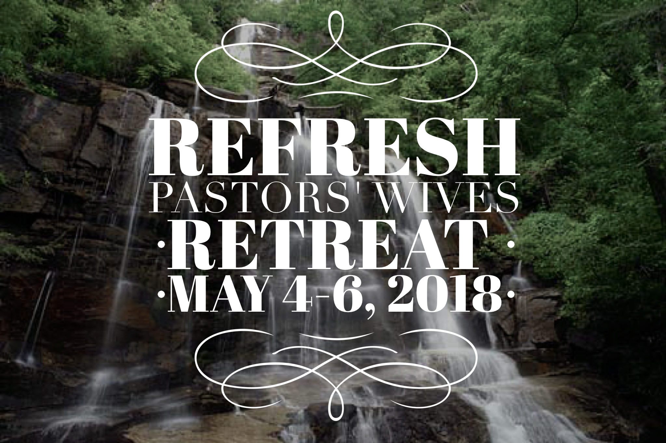

“I will REFRESH the weary and satisfy the faint.” Jeremiah 31:25  REFRESH Retreat has been specifically created to meet the needs of Pastors’ Wives.  During this weekend getaway, our prayer is that you will truly encounter God in a new way, find support and fellowship, and experience a time of refreshing and encouragement. Together, we will seek God, search for answers, and rest from the daily grind.  Our weekend starts on Friday evening with praise, prayer, and passionate preaching from our retreat speaker.  Saturday is filled with a variety of activities for you to connect with God and others, and learn valuable lessons to carry home with you.  Sunday morning will host a special intimate service intended to revitalize and encourage. You don’t want to miss this! |   Retreat Speaker  Sheri Hawley is an ordained minister with the Assemblies of God. She and her husband, Frank, serve as lead pastors of Garden Grove Church in Winter Haven, FL. Over twenty-five years of pastoral ministry, six years of evangelism, and thirty-eight years of marriage have given the Hawley’s an acute sensitivity to many of the needs in the body of Christ. For Sheri, women’s conferences and seminars are a particular passion. She has been traveling and ministering to women in the U.S. and abroad for over two decades now. Her greatest joy is seeing Jesus heal, restore, and minister to His precious daughters. | 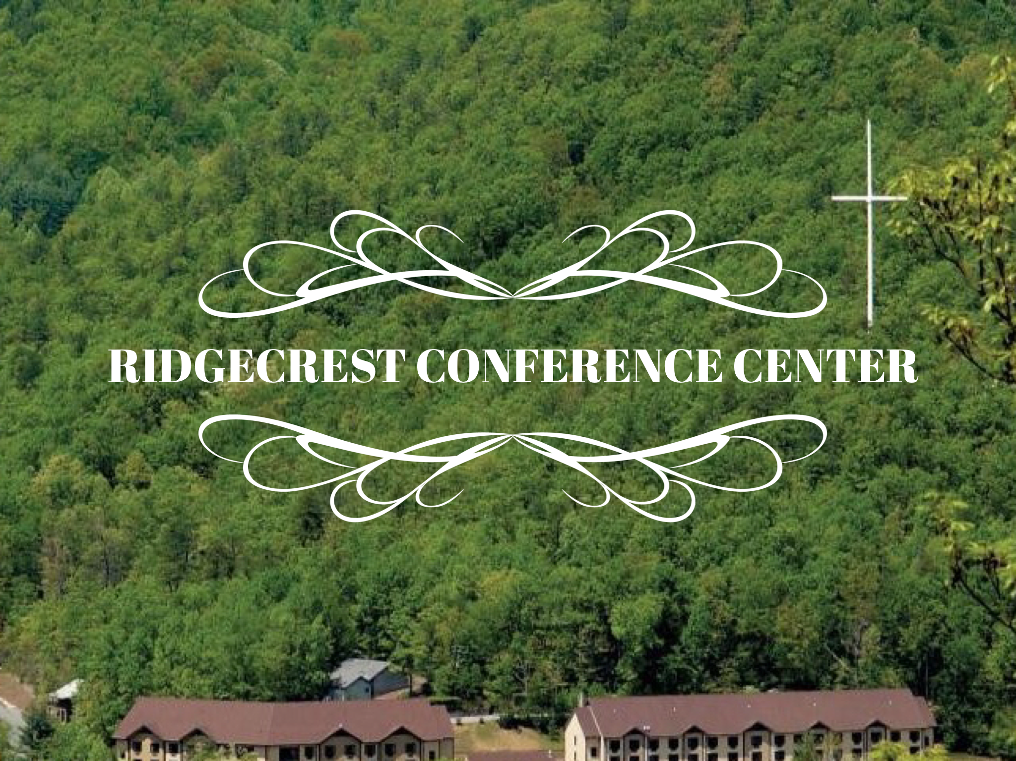  Ridgecrest is located 17 miles east of Asheville, North Carolina, on Interstate 40, Exit 66.  The PFWB Resource Center will provide a van from Dunn, NC for travelers who prefer not to travel on their own. This will be on a first come, first serve basis, so register early and request the PFWB transportation.  Contact Us  PFWB Resource Center  1200 Bud Hawkins Rd.  Dunn, NC 28334  Paula Holmes  paula.holmes@pfwb.org  910-892-4161  Gwen Carter  gwen.carter01@gmail.com  919-602-0821

